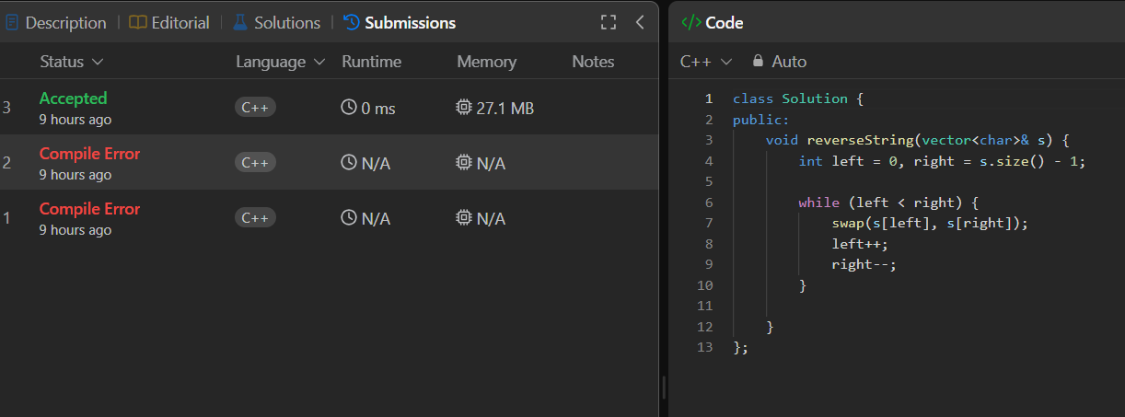

class Solution {
public:
void reverseString(vector<char>& s) {
int left = 0, right = s.size() - 1;

while (left < right) {
swap(s[left], s[right]);
left++;
right--;
}

}
};

